**Statement of purpose (SOP) for small Research Project which ends in a Research Article**

1. **Research Objectives:**

* Clearly define the primary objectives of your research. What specific goals are you aiming to achieve?
* Address the problem you’re investigating. What issue or challenge are you trying to solve?
* Briefly summarize relevant existing research related to your topic. Highlight key studies, theories, etc.
* Identify the knowledge gap you intend to fill. What existing gaps in literature or understanding will your research address?
* Explain how your research builds upon or contributes to the existing body of knowledge.

1. **Brief Methodology:**

* **Research Design:** Describe the overall approach you’ll take. Is it experimental, observational, or survey-based?
* **Data Collection:** Detail the methods you’ll use to gather data. Will you conduct surveys, interviews, experiments, or use existing datasets?
* **Data Analysis:** Outline the statistical or qualitative techniques you’ll apply to analyze the collected data.

1. **Expected Outcomes:**
   * Briefly mention the anticipated results or findings of your research. What do you hope to discover or contribute?
2. **Ethical Considerations:**

* Address any ethical concerns related to your research. Discuss how you’ll ensure participant confidentiality, informed consent, and compliance with ethical guidelines.
* If applicable, mention any necessary approvals that you’ll obtain.

1. **Timeline and Milestones:**

* Provide a rough timeline for your research project. Outline major milestones, deadlines, and expected completion dates.
* 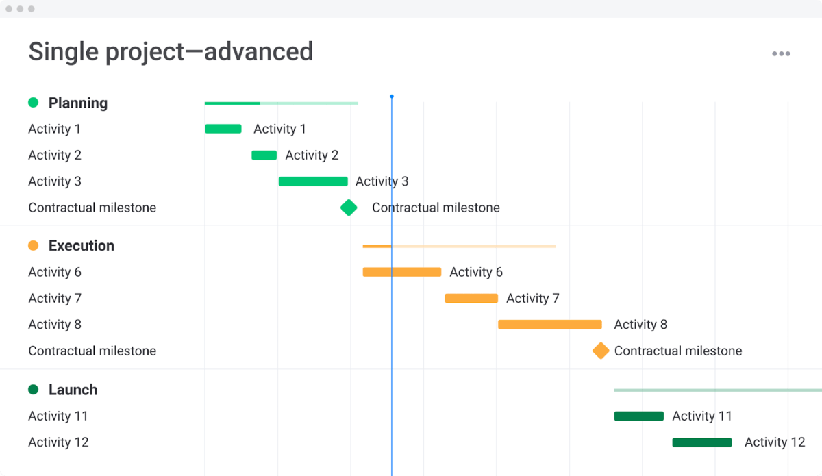Break down the project into phases (e.g., data collection, analysis, writing) and allocate time accordingly.

1. **Resources:**
   * Specify the resources you’ll need (e.g., access to databases, software, equipment, funding).
2. **Potential Collaborators/Co-Authors:**

* List any individuals or organizations you plan to collaborate with during the research process.
* Highlight the expertise, roles and responsibilities each potential collaborator will brings.